13 Jul-Plantaže ad Podgorica

Number: 6770/0710/1

Ordinal No. by the Plan of the Procurement : 2

Place and date: Podgorica, 07.10.2020.

REQUEST FOR COLLECTION OF THE BIDS FOR
THE PROCUREMENT PROCEDURE OF THE GOODS
- ALUMINIUM SCREW CAPS-

I Data on the Procurer

Procurer:  13 Jul Plantaže a.d. | Contact person:  Presiding of the Committee Filip Lalić
Adress: Put Radomira Ivanovića br.2 | Postal No. 81000
Main office: Podgorica | Fiscal Ident.No.(Comp.Reg.No.).02016281
Tel: 0038220 444 131 | Fax: 00382 20 658 025
E-mail: | filip.lalic@plantaze.com

II Subject of the procurement

- Type of the public procurement subject

x Goods

- Description of the procurement subject:
Aluminium screw caps

III Manner of the determination of the subject and assessed value of the procurement
□ Assessed value of the procurement subject
The procurement subject is procured:
By lots:

Lot 1 Alu screw caps for the bottle 1lit for the brandy: assessed value without VAT: € 5.690,00

Lot 2 Alu screw caps for the bottle 1 lit for wine: assessed value without VAT: €110.170,00

Lot 3 Alu screw caps for the bottle 0.187 lit for wine: assessed value without VAT: €171.700,00

TOTAL without VAT: € 287.560,00
TOTAL with VAT: € 347.947,60
IV Conditions for taking part in the procurement procedure

a)Compulsory conditions
Only a bidder who meets the following requirements may take part in the procurement procedure :
- Must be registered with the competent public authority for the registration of the business entities;
- Must prove that he or his legal representative has not been convicted by judgement absolute for any criminal offence as members of the organized crime with the corruption, money laundry and fraud;

Proof of the fulfillment of the compulsory conditions
The fulfillment of the compulsory conditions shall be proved by submitting the following proofs:
- Proof on the registration with the competent public authority for the registration of the business entities with the data on the authorized persons of the bidder;
- Proof by the competent authority, issued on the grounds of the criminal record which must not be older than 6 months by the day of public opening of the bids;

- Other conditions
Fulfillment of the other conditions shall be proved by submitting :

x Report on the Accounting and Financial State-Profit and Loss Account and Balance sheet with the Report of the Chartered Auditor in compliance with the Law on Accounting and Audit for the previous two years, ie for the period from the registration;

x List of the main deliveries, effected in previous two years

x Samples, descriptions, ie photographs of the goods that are the subject of the delivery,
the authenticity of which should be proved by the Bidder, in case that Procurer requests
it:

- A Bidder with whom we have not had a business co-operation in the concerned procurement so far or the subject of the procurement is a new product /closure ,should enclose, against the bid, 200 samples of the closures, respectively, with the technical specifications, for each item from the stated lots for which the Bidder submits the bid. Each of the enclosed samples should be clearly marked with the stated mark and number of the request for collecting the bids, number of the Lot for which the sample has been enclosed and name of the Bidder. The samples are delivered, against the bid in a separate envelope (package or similar), personally to the archive or by post to the address, denoted for the receipt of the bids. The name of the bidder with the mark of the seal should be denoted on the envelope (package or similar).

- Technical list of the goods, with the drawing and bill of measures

X measures for securing the food safety management system :
ISO 22 0000
A bidder should submit the proof that he holds the international standard for food safety
management .

x measures for securing quality management system:
ISO 9001
A bidder should submit the proof that he holds the international standard for quality management in the business organization
In case that the bidder is not the producer of the offered goods, he should submit ISO 22000 and ISO 9001 from the producer for the goods which has been the subject of his bid.

V Validity period of the bid

Validity period of the bid is 60 days from the day of the public opening of the bids.

VI Time limit and place of execution of the Contract

- Time limit for the execution of the Contract is one year from the day of the conclusion of the Contract, ie from the day of the conclusion of the Contract until the consumption of the agreed value ,if it appears first as the circumstance.
-The place of the execution of the Contract is Procurer’s warehouse Podgorica.

VII Language of the bid

x Montenegrin and other languages in official use in Montenegro /English

VIII Time limit and place of submitting the bids and opening of the bids

The bids shall be submitted on working days from 08:00 to 15:00 hrs, closing on 22/10/2020 by 12:00 hrs.
The bids may be submitted:

□ x directly, in person at the Procurer’s archive to the following address: Put Radomira Ivanovića No.2, Podgorica.

□x by registered mail with the advice of receipt to the following address: Put Radomira Ivanovića No.2, Podgorica.

Public opening of the bid, which may be attended by the authorized representatives of the bidders with enclosed power of attorney, signed by the authorized person, will be held on the 22nd of October , 2020 at 12:15 hrs in the premises of 13 jul-Plantaže a.d., located in Put Radomira Ivanovića Str, No.2, 81 000 Podgorica.

X Criteria for the selection of the most favourable bidder

- the lowest offered price

* Note: Procurer retains the right to select several bidders for the lots of big volumes in order to make possible the continuous process of production and the first ranked bidder should have at least 60% of the procurement by a concerned lot which shall be shared.

XI Other data and conditions which are important for the implementation of the procurement procedure

The deadline and method of payment
The payment deadline is: min 45 days from the day of issuance of the invoice
Method of payment: by bank transfer

The deadline, manner and place of delivery
The payment deadline for all lots is: 15 working days from the day of placing the written order Manner of delivery: in succession, depending on the Procurer’s needs
Place of delivery: Procurer’s warehouse, Podgorica

Means of financial security of the Contract on Procurement

A bidder whose bid shall be selected as the most favourable and with whom the Contract shall be made for the first time, is obliged, prior to the conclusion of the Contract on Procurement ,to submit to Procurer as follows:
X guarantee for good performance of the Contract in the amount of 5% of the Contract value.

TECHNICAL CHARACTERISTICS OR SPECIFICATIONS OF THE SUBJECT OF THE PROCUREMENT

General terms:

Manner of packaging:

The closures are packed in the polyethylene bags and cardboard boxes. The packaging should provide a sterile packaging of the closures. Number of single packaging in a collective packaging , complied with the manufacturer‘s practice. The boxes are stacked on the Euro pallets. Single, group and transport packagings should be denoted by the proper declaration.

Content of the declaration:

Manufacturer, manufacturer’s address, name of the purchaser, name of the product, quantity, production date, recommendation on the time of use, lot, the country of the origin of the product.

The other data should be provided in the Certificate of Quality, provided with each delivery

Lot 1.- Aluminium screw caps for the bottle 1 lit (brandy)

PARTICULAR CONDITIONS:

Ord.No. | Description of the subject of the procurement, ie a part of the subject of procurement | Important characteristics of the subject of the procurement concerning quality, performances and/or measures | Unit of measure | Quantity
1. | Screw cap for the brandy (red) | Type of the neck of the bottle: EN15543:2008  Height, H: 55 + 0,5 mm  Outer diameter, D: 31,5 + 0,3 mm  No of bridges: 9  Moment of breaking the bridges : 9,18-23,05 [Kg cm]  Weight of the closure :7 – 8 g  Manufacture :  Material of the closure: alloy 8011  hardness H14/H13  Thickness of the sheet metal : min 0,22mm  Material of the insertion: EPE  Height of the insertion:1,8+10%  Material of the valve: PE and PS  Height of the valve: 22,5 mm  Colour : Red PMS 193-by the sample  Print:Offset printing  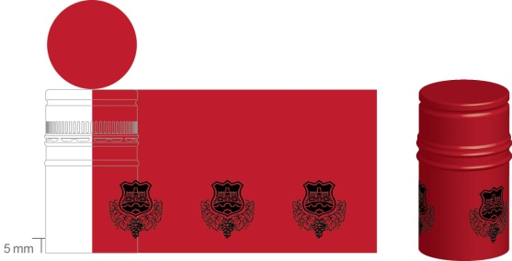 | pc | 50.000
2. | Screw cap for the brandy (gray) | Type of the neck of the bottle: EN15543:2008  Height, H: 55 + 0,5 mm  Outer diameter, D: 31,5 + 0,3 mm  No of bridges: 9  Moment of breaking the bridges : 9,18-23,05 [Kg cm]  Weight of the closure :7 – 8 g  Manufacture :  Material of the closure: alloy 8011  hardness H14/H13  Thickness of the sheet metal : min 0,22mm  Material of the insertion: EPE  Height of the insertion:1,8+10%  Material of the valve: PE and PS  Height of the valve: 22,5 mm  Colour : grey (silver)-by the sample  Print:Offset printing  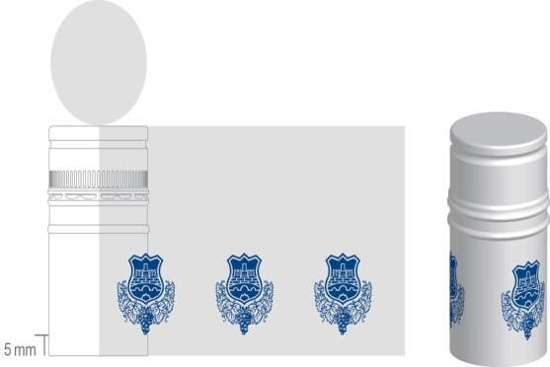 | pc | 15.000
3. | Screw cap for brandy (peach) | Type of the neck of the bottle: EN15543:2008  Height, H: 60 + 0,5 mm  Outer diameter, D: 31,5 + 0,3 mm  No of bridges: 9  Moment of breaking the bridges : 8,05-23,00 [Kg cm]  Weight of the closure :7 – 8 g  Thickness of the sheet metal : min 0,22mm  Manufacture :  Material of the closure: alloy 8011A  hardness H14/H13  Thickness of the sheet metal : min 0,22mm  Material of the insertion: EPE  Height of the insertion:1,8+10%  Material of the valve: PE and PS  Height of the valve: 22,5 mm  Colour : 12-0913 TPX -by the sample  Print: hot foil  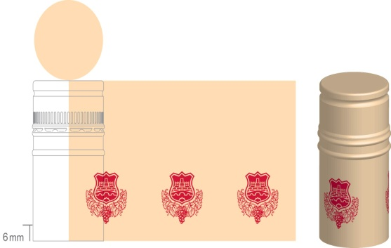 | pc | 15.000

Lot 2 – Aluminium screw caps for the bottle 1 lit (wine)

Ord.No. | Description of the subject of the procurement, ie a part of the subject of procurement | Important characteristics of the subject of the procurement concerning quality, performances and/or measures | Unit of measure | Quantity
1. | Screw cap for wine (black) | Type of the neck of the bottle: EN15543:2008  Height, H: 60 + 0,2 mm  Outer diameter, D: 29.7 + 0,3 mm  No of bridges: 8  Moment of breaking the bridges : 8-23 [Kg cm]  Weight of the closure :4– 5 g  Manufacture:  Material of the closure: alloy 8011A  hardness H14/H13  Thickness of the sheet metal : min 0,22mm  Material of the insertion: Saranex  Mass of the insertion: 1.8+10%  Colour : black -by the sample  Print: offset printing | pc | 2.700.000
2. | Screw cap for wine (gold) | Type of the neck of the bottle: EN15543:2008  Height, H: 60 + 0,2 mm  Outer diameter, D: 29.7 + 0,3 mm  No of bridges: 8  Moment of breaking the bridges : 8-23 [Kg cm]  Weight of the closure :4– 5 g  Manufacture:  Material of the closure: alloy 8011A  hardness H14/H13  Thickness of the sheet metal : min 0,22mm  Material of the insertion: Saranex  Mass of the insertion: 1.8+10%  Colour : gold -by the sample  Print: offset printing | pc | 500.000
3. | Screw cap for wine (red) | Type of the neck of the bottle: EN15543:2008  Height, H: 60 + 0,2 mm  Outer diameter, D: 29.7 + 0,3 mm  No of bridges: 8  Moment of breaking the bridges : 8-23 [Kg cm]  Weight of the closure :4– 5 g  Manufacture:  Material of the closure: alloy 8011A  hardness H14/H13  Thickness of the sheet metal : min 0,22mm  Material of the insertion: Saranex  Mass of the insertion: 1.8+10%  Colour : red  Print: offset printing | pc | 287.000
4. | Screw cap for wine (white) | Type of the neck of the bottle: EN15543:2008  Height, H: 60 + 0,2 mm  Outer diameter, D: 29.7 + 0,3 mm  No of bridges: 8  Moment of breaking the bridges : 8-23 [Kg cm]  Weight of the closure :4– 5 g  Manufacture:  Material of the closure: alloy 8011A  hardness H14/H13  Thickness of the sheet metal : min 0,22mm  Material of the insertion: Saranex  Mass of the insertion: 1.8+10%  Colour : white matt-by sample  Print: hot foil | pc | 400.000
5. | Screw cap for wine (black) | Type of the neck of the bottle: EN15543:2008  Height, H: 60 + 0,2 mm  Outer diameter, D: 29.7 + 0,3 mm  No of bridges: 8  Moment of breaking the bridges : 8-23 [Kg cm]  Weight of the closure :4– 5 g  Manufacture:  Material of the closure: alloy 8011A  hardness H14/H13  Thickness of the sheet metal : min 0,22mm  Material of the insertion: Saranex  Mass of the insertion: 1.8+10%  Colour : black-by sample  Print: no print | pc | 130.000

Lot 3- Aluminium screw caps for the bottle 0,187 lit – (wine)

Ord.No. | Description of the subject of the procurement, ie a part of the subject of procurement | Important characteristics of the subject of the procurement concerning quality, performances and/or measures | Unit of measure | Quantity
1. | Screw cap for wine (black) | Type of the neck of the bottle: EN15543:2008  Height, H: 44+ 0,2 mm  Outer diameter, D: 28.7 + 0,3 mm  No of bridges: 8  Moment of breaking the bridges : 6,9-18,40 [Kg cm]  Thickness of the insertion :2,0 mm +10%  Material of the insertion: Saranex  Weight of the closure: 3-3,1 g  Manufacture of the closure: alloy 8011  Thickness of the sheet metal: min 0,22 mm  Hardness H14/H13  Colour : black matt-by sample  Print: offset printing  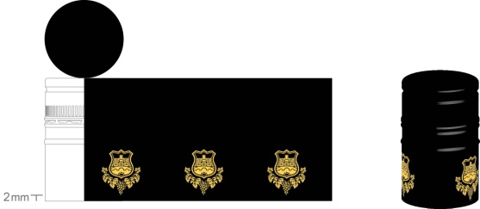 | pc | 1.600.000
2. | Screw cap for wine (white) | Type of the neck of the bottle: EN15543:2008  Height, H: 44+ 0,2 mm  Outer diameter, D: 28.7 + 0,3 mm  No of bridges: 8  Moment of breaking the bridges : 6,9-18,40 [Kg cm]  Thickness of the insertion :2,0 mm +10%  Material of the insertion: Saranex  Weight of the closure: 3-3,1 g  Manufacture of the closure: alloy 8011  Thickness of the sheet metal: min 0,22 mm  Hardness H14/H13  Colour : white semi- matt-by  sample  Print: offset printing  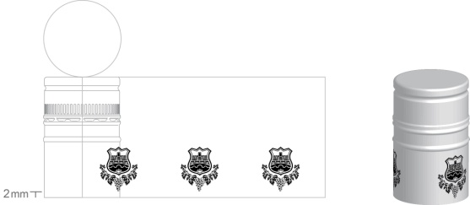 | pc | 1.775.000

-As for the concerned procurement,Bidder should provide the authorization ,issued by the manufacturer, that he maz offer and deliver the goods, requested by this concerned competition or a valid proof that the manufacturer is the authorized dealer for the concerned procurement.

The quantity of taking over of the goods by shipments:

For the Lot 1- total quantity of the goods shall be taken over by two shipments.
For the Lots 2, 3- min.quantity of taking over of the goods by one shipment shall be cc.300.000 pcs;
The time schedule of the deliveries of the goods shall be precisely defined upon the conclusion of the contract with the selected bidder.

Note:

Bidder should assume the obligation to have at his stock, at any moment, during the validity of the Contract, minimal reserves of 200.000 pcs, respectively, ready to be taken over (Lots 2 and 3).

For all lots,the following guarantees of quality are requested:

1. Manufacturer’s specification of the closures, sealed by the manufacturer.
2. Manufacturer’s specification of the raw material of which the closure has been made, sealed by the manufacturer (sheet metal, insertion)

Manner of implementation of quality control

During the validity of the Contract, the qualitative reception of the goods shall be done by an authorised Procurer’s person, for each delivery, on delivery date, implying the control of the parameters, given in the specification and the authorised external labs shall be engaged, if needed.
Packaging control shall be done at the receipt of each delivery and the quality of closures by random selection of the samples in compliance with the parameters, given in the specification. At bottling, the control shall be also arranged and the records shall be kept on the irregularities, determined during bottling.
Procurer shall determine the nuance of the colour of the submitted samples visually, comparing the samples, provided by the bidder with the control sample of the Procurer and the dimensions shall be determined by measuring , in compliance with the specification.

NOTE:

By the concerned Request, Procurer states all his needs for the concerned goods at the annual level, aiming , upon receipt, check and evaluation of all bids, to make a decision on a possible business co-operation with potential bidder. Procurer’s Committee will check and evaluate each bid that has arrived.

Procurer is not limited to conclude the Contract to one potential supplier only, but he may conclude a Contract on the Procurement for the same lot of the concerned goods with several suppliers. The reason for this is that it is necessary for preserving the production process, particularly bearing in mind that the production process at Procurer’s has directly been conditioned by the procurement of the concerned goods, so it is necessary to provide regular, continuous and qualitative supply of the Procurer with that goods. Violation of the agreed obligations by Supplier, regardless the Supplier’s failure and objective circumstances , would cause, undoubtedly, immense negative consequences for the Procurer, in sense of damage occurrence .

Concerning the above mentioned, Procurer should not allow to depend on one Supplier only. Therefore, Procurer retains the right to share the stated quantities of the concerned goods to several suppliers, not limiting himself to the fact that the bids relate to whole, specified quantity by lots. In any case, upon the receipt of the bids, Procurer retains the right to negotiate on the conditions for the conclusion of the Contract with every bidder.

As for the suppliers with whom we have not had the business co-operation in the concerned procurement so far or when the subject of the bid is a new product/bottle, the evaluation of the quality assurance will have eliminatory character, ie only the bidders whose samples pass successfully the quality control, shall be considered in the procedure of checking and evaluation of the bids.

Bidders with whom we have not had so far the business co-operation and concluded contracts and Committee determines that their bid is correct ,as provided by the Request and competitive, will get an opportunity, by concluding the Contract on Procurement , to deliver smaller-trial quantities in order to check the quality of the concerned goods and follow the agreed obligations by Supplier. The reason for this is that the check of the quality of the concerned goods, considering its characteristics and properties, shall not be possible in a short period of time, but it takes longer period of time to be checked.

Procurer retains the right, upon opening and checking the bids that have arrived, to ask the explanation or addition to the accompanying documentation by Procurer.

Considering huge instability and uncertainty on the market, due to the pandemic Covid-19, Procurer retains the right not to take over all requested quantities, in case that business changes would be of such a volume that they could affect the business stability of a Procurer, paying attention, at the same time, that disproportionate damage shall not be caused to the suppliers. The manner and volume of the realisation of this right shall be the subject of making an agreement with the selected suppliers.

FORM OF THE BID WITH THE FORMS, PREPARED BY THE BIDDER

COVER PAGE OF THE BID

(title of the Bidder)
____________________________
Submits to

(title of Procurer)
_____________________

BID

By the Request for Collection of the Bids No._________ dated from__________year
for procurement of the aluminium screw caps

Lot 1 Alu screw caps for the bottle 1lit for the brandy: assessed value without VAT: € 5.690,00

Lot 2 Alu screw caps for the bottle 1 lit for wine: assessed value without VAT: €110.170,00

Lot 3 Alu screw caps for the bottle 0.187 lit for wine: assessed value without VAT: €171.700,00

DATA ON THE BID AND BIDDER

The bid is submitted as:

□ individual bid
□ individual bid with the subcontractor
□joint bid
□joint bid with the subcontractor

Data on the bidder of the individual bid:

Title and main office of the Bidder

Fiscal Identification Number

VAT

Account No and title of the Bidder’s bank

Address

Telephone

Fax

E-mail

Entity/-ies authorized for signing the financial part of the bid and documents in the bid | (Name, surname and function)
 | (signature)
Name and surname of the entity in charge for information

FINANCIAL PART OF THE BID FOR LOT _____

Ord.No. | description of the subject | essential characteristics of the offered subject of procurement | measure unit | quantity |  | unit price without VAT | total amount  without VAT | VAT | total amount  with VAT | VAT
1
2
3
Total price without VAT

VAT
Total amount with VAT
- by numbers
- by letters

Conditions of the Bid :
Time limit for the Contract execution
Place for the Contract execution
Time limit for payment
Method of payment
Time limit of delivery
Manner of delivery
Place of delivery
Manner of packaging
Warranty of quality
Manner of implementation of quality control
Validity period of the bid

Authorised entity of the Bidder
___________________________________
(name, surname and function)
_____________________________________
(signature by own hand) PLACE OF SEAL

NOTE: Bidder is obliged for each lot for which he participates to submit ,in the offer, the form Financial part of the bid with the indication for which lot he participates and for each lot, a single form with all data, indicated in that form.

PROOFS OF THE FULFILLMENT OF MANDATORY CONDITIONS FOR PARTICIPATION IN THE PROCEDURE OF PUBLIC COMPETITION

To submit:

- proof of the registration, issued by the body, competent for the registration of the business companies with the data on the authorized persons of the Bidder;

- proof of the competent body, issued by the Criminal records for the legal and authorized entity that must not be older than six months until the day of the public opening of the bids.

PROOFS OF FULFILLMENT OF THE CONDITIONS FOR KNOW-HOW-TECHNICAL AND PROFESSIONAL EXPERTISE

Fulfillment of the other conditions shall be proved by submitting the following documents:
x Report on the Accounting and Financial State-profit and Loss Account and Balance sheet with the Report of the Chartered Auditor in compliance with the Law on Accounting and Audit for the previous two years, ie for the period from the registration;

x List of the main deliveries, effected in previous two years, with the quantities, dates and
recipients against submission of the confirmations of the effected deliveries, issued by
the Purchaser

x Samples, descriptions, ie photographs of the goods that are the subject of the delivery,
the authenticity of which should be proved by the Bidder, in case that Procurer requests
it:

- A Bidder with whom we have not had a business co-operation in the concerned procurement so far or the subject of the procurement is a new product /closure ,should enclose, against the bid, 200 samples of the closures, respectively, with the technical specifications, for each item from the stated lots for which the Bidder submits the bid. Each of the enclosed samples should be clearly marked with the stated mark and number of the request for collecting the bids, number of the Lot for which the sample has been enclosed and name of the Bidder. The samples are delivered, against the bid in a separate envelope (package or similar), personally to the archive or by post to the address, denoted for the receipt of the bids. The name of the bidder with the mark of the seal should be denoted on the envelope (package or similar).

- Technical list of the goods, with the drawing and bill of measures

X measures for securing the food safety management system :

ISO 22 0000
A bidder should submit the proof that he holds the international standard for food safety
management .

x measures for securing quality management system:

ISO 9001
A bidder should submit the proof that he holds the international standard for quality management in the business organization.

In case that the bidder is not the producer of the offered goods, he should submit ISO 22000 and ISO 9001 from the producer for the goods which has been the subject of his bid.

Note:

The bidder, whose bid shall be selected as the most favourable and with whom the contract shall be concluded for the first time, is obliged to submit the following document to Procurer, prior to the conclusion of the Contract:

X guarantee for good performance of the contract in the amount of 5% of the contract value

THE LIST OF MAIN DELIVERIES OF THE CONCERNED CLOSURES IN LAST TWO YEARS
( 2018. and 2019.)

Ord.No. | Recipient(Purchaser) | No and date of conclusion of the Contract | Year of the realization of the Contract | Quantity (pc) | Contact of the recipient (purchaser)
1
2
3
…

The integral part to the List of main deliveries of the goods in last 2 years are confirmations on the executed deliveries, issued by the purchasers.

Authorised person of the bidder

____________________________

(name, surname and function)

________________________________
(signature in his own hand)

SEAL OF SIGNATURE

INSTRUCTIONS TO THE BIDDERS FOR MAKING AND SUBMITTING THE BIDS

Preparation of the bid
A bidder makes and submits the bid in compliance with this request for taking part in the procurement procedure.
Manner of submission of the bid
A bid is delivered in the appropriate, closed envelope (an envelope, box and similar). It is on one part of the envelope that the title and main office of the Procurer, number of the Request for Collection of the Bids and the text with the inscription: ‘Do not open before the public opening of the bids’ should be written, and on the other part of the envelope, the title, main office and the address of the Bidder should be written.
Manner of stating the offered price
A bidder submits the bid with the price (-s), expressed in EUR, without VAT, such as: unit price, quantity and total financial amount for the offered goods, VAT amount and total amount, including VAT.
All costs and discounts, concerning the total offered price are included in the offered price.
Note: Bidder who is not a tax payer of Montenegro expresses the offered price/es without included VAT.
Offered price is expressed for each lot , respectively.
Due time of the bid
A bid is considered submitted in due time if it is delivered to the Procurer prior to the expiry of the time limit, provided for submitting the bids, stipulated by this Request.
Recommendation to the bidders
A bid should be prepared as a single compound and each filled page of the bid should be numbered and sealed.

